BESS FROM PV ARRAY USING BOOST CONVERTER

SYSTEM WORKING OVERVIEW:
The system is a two-stage DC-DC power conversion architecture designed for renewable energy microgrids.
- Stage 1 (Boost Converter): Steps up the variable, low voltage from the Solar PV array (~150V) to a stable, elevated intermediate DC-bus voltage (~270V to 300V).
- Stage 2 (Half-Bridge Converter): Operates bidirectionally. When solar generation is high, it operates in Buck mode to step down the DC-bus voltage to smoothly charge the battery (~160V). When solar generation drops, it seamlessly switches to Boost mode to extract power from the battery and support the central DC-bus load.

2. Design Formulas

Stage 1: PV Boost Converter Sizing
Duty Cycle of the Boost Stage (D_boost): D_boost = 1 - (V_in / V_out)
Boost Inductor Selection (L_boost): L_boost = (V_in * D_boost) / (Delta_I_L * f_s) Where: V_in = Solar input voltage (V) D_boost = Boost converter duty cycle Delta_I_L = Allowed peak-to-peak inductor current ripple (A) f_s = Switching frequency (Hz)
PV Input Parallel Capacitor Sizing (C_in_pv): C_in_pv = (I_out * D_boost) / (Delta_V_in * f_s) Where: I_out = Boost converter output current (A) Delta_V_in = Allowed input voltage ripple (V)

Intermediate DC-Link Sizing
Central DC-Bus Capacitor Selection (C_dc_link): C_dc_link = (I_load * D_max) / (Delta_V_out * f_s) Where: I_load = Current drawn by the microgrid load (A) D_max = Maximum operating duty cycle Delta_V_out = Allowed DC-bus voltage ripple tolerance (V)
Load Resistor Calculation (R_load): R_load = (V_dc^2) / P_load Where: V_dc = Target central DC-bus voltage (V) P_load = Total power required by the microgrid load (W)

Stage 2: Synchronous Half-Bridge Sizing
Nominal Charging Duty Cycle (D_hb): D_hb = V_batt / V_out Where: V_batt = Nominal battery bank voltage (V) V_out = Central DC-bus voltage (V)
Battery Filter Inductor Selection (L_batt): L_batt = ((V_out - V_batt) * D_hb) / (Delta_I_batt * f_s) Where: Delta_I_batt = Allowed charging current ripple tolerance (A)

Closed-Loop Control System (PI Block)
Parallel Form PI Transfer Function (G_c): G_c(s) = K_p + (K_i / s) Where: K_p = Proportional Gain constant K_i = Integral Gain constant s = Laplace complex frequency variable

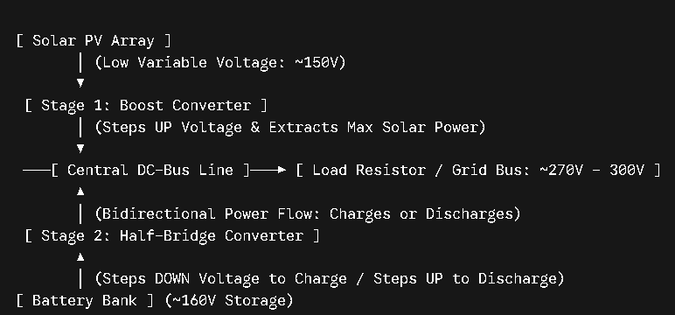

1. Primary Commercial Applications

☀️ 1. SOLAR PV ENERGY STORAGE SYSTEMS (ESS)
In standard grid-tied or off-grid solar setups, solar panels cannot directly charge a battery bank efficiently or safely on their own.
- The Problem: Solar panel voltages fluctuate wildly based on sunlight intensity, while batteries demand strict, regulated currents to avoid exploding or degrading.
- Your System's Solution: The Boost Converter (Stage 1) acts as the harvester—it takes low, variable voltage from the PV panels (150V) and steps it up to a high, stable DC bus voltage (270V–300V). The Half-Bridge Synchronous Converter (Stage 2) then takes that high-voltage bus and steps it down safely to the battery's specific nominal chemistry level (160V) to charge it smoothly.

🚗 2. Electric Vehicle (EV) Regenerative Fast-Charging Stations
This exact circuit structure is the backbone of modern EV infrastructure.
- When charging from local solar canopies, the power flows forward: PV → Boost Converter → DC Bus → Half-Bridge → Vehicle Battery.
- When managing grid peaks, these stations use V2G (Vehicle-to-Grid) technology. Because your half-bridge layout is bidirectional, it can reverse power flow completely, taking energy out of the battery pack and boosting it back up to the DC bus to support external loads when the sun goes down.

🏢 3. Uninterruptible Power Supplies (UPS) & Data Centers
Data centers run entirely on sensitive DC power grids. If the main power lines fail, servers will instantly crash.
- Your project represents an online UPS system. The Boost stage continuously collects green power from renewables, while your half-bridge control loop sits in active standby. The moment an outage occurs, the half-bridge instantly reverses its current path within microseconds—switching from charging mode to discharging mode—to keep the local load resistor fully powered without a single millisecond of interruption.

2. Academic and Engineering Merits of Your Model
If you are writing a report, thesis, or presenting this project to an evaluator, you have successfully demonstrated mastery over three advanced power electronic milestones:
- Decoupled Two-Stage Architecture: You successfully linked a current-source input stage (PV) to a voltage-source output stage (Battery) without letting their individual high-frequency switching dynamics crash the simulator.
- Synchronous Rectification: By utilizing a complementary half-bridge layout with a NOT gate instead of a standard lossy diode, you built a high-efficiency synchronous buck-boost converter. This reduces internal thermal losses significantly in real hardware.
- Closed-Loop Active Damping: Your PI controller demonstrates how automated feedback loops can handle massive start-up energy surges (the high-current ringing seen in the first 0.05 seconds) and damp them down into perfect steady-state equilibrium without blowing physical fuses.

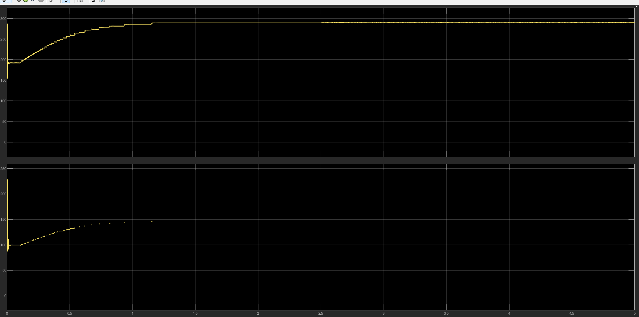
BATTERY OUTPUT:
